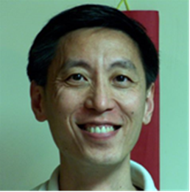 **A message from the President**

Dear CESASC members and friends,

Greetings!

I am very honored to be your president of CESASC in 2015-2016 term. CESASC has a rich tradition and history for more than 50 years. CESASC board of directors is determined to carry on the tradition and serve you in our best ability for the coming year.

About CESASC, I have a personal story to share. At the time I was a graduate student (some time ago), my first participation to the southern California Chinese American activities was CESASC Annual Convention. I was very impressed by the caliber of this professional Association then. Now, I am serving as the president of this great Association. Life is a circle, indeed.

Sciences and technologies are evolving fast in contemporary time. We need to advance with them. Our Association should be a leader and a platform for professionals to do just that. Throughout the year, we are going to have many activities that will serve both the scientific community and Chinese American community. Continuing with our regular technical seminars and symposiums, radio/TV shows, and community events, we are also planning to initiate a series of seminars for Chinese American career readiness, leadership, and success in America.

Please participate in and join us to make our Association more professional and vivacious. Hope to see you all in every occasion and function related to CESASC. Without your involvement, CESASC would not be successful.

Thank you for your supports and participation.

Sincerely,

Yue Rong, Ph.D. (aka, YR)

President 2015-2016